UNIVERSIDAD TECNOLÓGICA DEL PERÚ

FACULTAD DE CIENCIAS DE LA SALUD
Herramientas digitales para el aprendizaje
CARRERA: MEDICINA HUMANA
CICLO ACADÉMICO: 2026-II

Título: TAREA ACADÉMICA 1

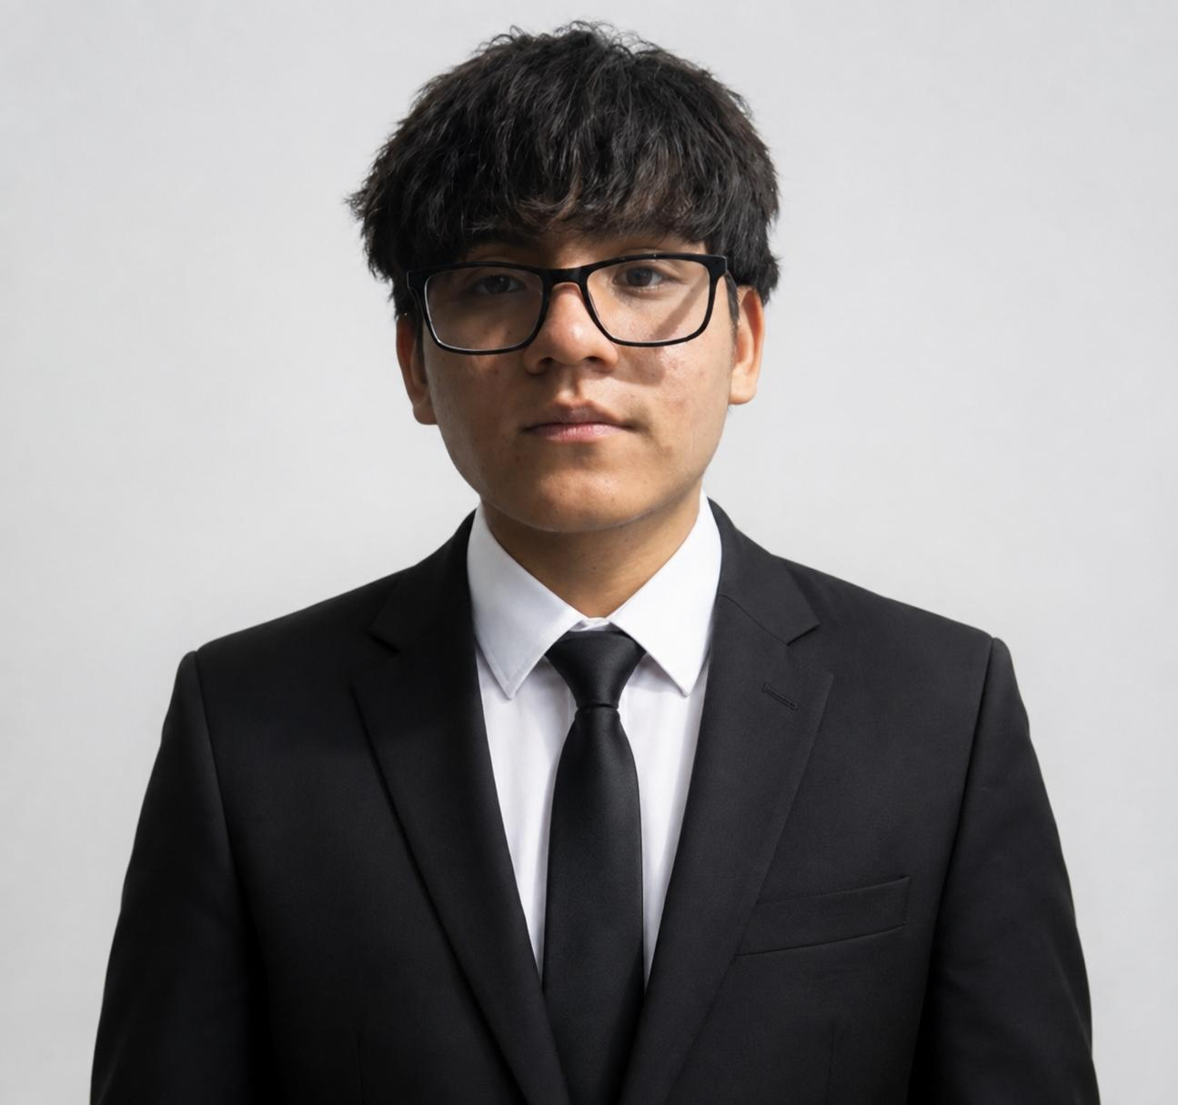 |  | 
PANDURO REBAZA, MOISES ALEJANDRO  Codigo: U26285546 | Gutierrez Cueva Dowlin Jabel  Codigo: U26285335 | Parra Mendoza Anjhelyt  Codigo: U26264992

DOCENTES:
- Alvarado Huayhuaz, Jesus Antonio
- Jimenez Garay, Jenny Marianella
- Libon Sipiran, Juan Antonio

LIMA - PERÚ
2026

EVIDENCIA
1-. TABLA-FÓRMULA
P | E | C | O
Age | Sedentary Behavior | Exercise | Cardiovascular Diseases
Aged, 80 and over | Life Style | Motor Activity | Heart Disease
Frail Elderly | Health Behavior | Walking | Vascular Diseases

2-. Fórmula de PubMed
P:
(("Elder Nutritional Physiological Phenomena"[Mesh]) OR ( "Aged, 80 and over/physiology"[Mesh] OR "Aged, 80 and over/statistics and numerical data"[Mesh] )) OR "Frail Elderly/statistics and numerical data"[Mesh]
E:
(("Sedentary Behavior/history"[Mesh]) OR ( "Life Style"[Mesh] OR "Healthy Lifestyle"[Mesh] )) OR ( "Health Behavior"[Mesh] OR "Health Risk Behaviors"[Mesh] )
C:
(("Exercise"[Mesh] OR "Warm-Up Exercise"[Mesh]) OR "Motor Activity/physiology"[Mesh]) OR "Walking"[Mesh]
O:
(("Cardiovascular Diseases"[Mesh]) OR "Heart Diseases"[Mesh]) OR "Vascular Diseases"[Mesh]
PECO:
(("Elder Nutritional Physiological Phenomena"[Mesh]) OR ( "Aged, 80 and over/physiology"[Mesh] OR "Aged, 80 and over/statistics and numerical data"[Mesh] )) OR "Frail Elderly/statistics and numerical data"[Mesh]
AND
(("Sedentary Behavior/history"[Mesh]) OR ( "Life Style"[Mesh] OR "Healthy Lifestyle"[Mesh] )) OR ( "Health Behavior"[Mesh] OR "Health Risk Behaviors"[Mesh] )
AND
(("Exercise"[Mesh] OR "Warm-Up Exercise"[Mesh]) OR "Mo
tor Activity/physiology"[Mesh]) OR "Walking"[Mesh]
AND(("Cardiovascular Diseases"[Mesh]) OR "Heart Diseases"[Mesh]) OR "Vascular Diseases"[Mesh]
3-. Fórmula de Scopus
TITLE-ABS-KEY("elder nutritional physiological phenomena" OR "aged, 80 and over" OR "frail elderly")
AND
TITLE-ABS-KEY("sedentary behavior" OR "life style" OR "healthy lifestyle" OR "health behavior" OR "health risk behaviors")
AND
TITLE-ABS-KEY("exercise" OR "warm-up exercise" OR "motor activity" OR "walking")
AND
TITLE-ABS-KEY("cardiovascular diseases" OR "heart diseases" OR "vascular diseases")
4-. Preguntas
¿Cuántos documentos obtuviste?
-Se obtuvieron 2.070.343 documentos publicados entre los años 1944 y 2027. Al aplicar el filtro correspondiente al periodo 2026–2027, se obtuvieron 39.961 resultados.
¿Cuántos son artículos originales de investigación?
- Se identificaron 2.311 artículos originales de investigación.
¿Cuántos son revisiones?
-Se identificaron 7.632 artículos de revisión
LINK DE GITHUB:
-https://github.com/anjhelytparra-alt/Fuente--pregunta-de-investigaci-n-

